 | 28 Editors - Asset Browser
Table of content
Detailed table of content 2
Asset Browser 5
How to 5
Asset handling 5
Asset Library 6
Drag n Drop of materials 7
Header 7
Header - View menu 8
Source List 8
File Path 8
Frame Selected 8
Display Size 8
Area Menu 8
Header - Select menu 9
Box Select 9
Inverse 9
None 9
All 9
Header - Catalog menu 9
Undo 9
Redo 9
Asset Library Paths 10
Save Asset Catalogs 10
New Asset Catalog 10
Header - Asset menu 10
Paste as new asset 10
Create Pose Asset 10
Header - Tools and Options 10
Drop Instance Collections at Origin 11
Drop Collections as Instances 11
Import Method 11
Display Mode 11
Search 12
Filter 12
Toggle Region 12
Drop collection as Instances 12
Import Method 12
Tool shelf 13
Asset Library chooser 13
Asset Catalogs 13
Unassigned 14
Asset catalog right click menus 14
Sidebar 15
Name 15
Info Panel 15
Preview Panel 16
Tags Panel 16
Assets context menu 16
Refresh Asset Library 17
Clear Asset 17
Clear Asset ( Set Fake User) 17
Open Blend File 17
Display Size 17
Pose Assets context menu 17
Apply Pose 17
Apply Pose Flipped 17
Blend Pose 17
Select Pose Bones 18
Deselect Pose Bones 18
Assign Action 18

Detailed table of content

Detailed table of content
Detailed table of content 2
Asset Browser 5
How to 5
Asset handling 5
Asset Library 6
Drag n Drop of materials 7
Header 7
Header - View menu 8
Source List 8
File Path 8
Frame Selected 8
Display Size 8
Area Menu 8
Horizontal Split 8
Vertical Split 8
Duplicate Area into new Window 8
Toggle Maximize Area 8
Toggle Fullscreen Area 8
Close Area 9
Header - Select menu 9
Box Select 9
Inverse 9
None 9
All 9
Header - Catalog menu 9
Undo 9
Redo 9
Asset Library Paths 10
Save Asset Catalogs 10
New Asset Catalog 10
Header - Asset menu 10
Paste as new asset 10
Create Pose Asset 10
Header - Tools and Options 10
Drop Instance Collections at Origin 11
Drop Collections as Instances 11
Import Method 11
Follow Preferences 11
Link 11
Append 11
Append (Reuse Data) 11
Display Mode 11
Vertical List 11
Horizontal List 11
Thumbnails 11
Display mode options 12
Vertical / Horizontal List 12
Size 12
Date 12
Thumbnails 12
Tiny / Small / Medium / Large Buttons 12
Size 12
Search 12
Filter 12
Toggle Region 12
Drop collection as Instances 13
Import Method 13
Follow Preferences 13
Link 13
Append 13
Append (Reuse Data) 13
Tool shelf 13
Asset Library chooser 13
Current File 13
User Library 14
Refresh 14
Asset Catalogs 14
Save Asset Catalogs 14
New Asset Catalog 14
Unassigned 15
Asset catalog right click menus 15
Right clicking at the All item 15
Mark as asset 15
Clear Asset 15
Right clicking at one of the catalog items 15
New Catalog 15
Delete catalog 15
Rename 15
Mark as asset 15
Clear Asset 15
Sidebar 15
Name 16
Info Panel 16
Source 16
Description 16
Author 16
Preview Panel 16
Load Custom Preview 16
Generate Preview 16
Tags Panel 16
Tags List 16
Drag handler 17
Search 17
Add Asset Tag 17
Remove Asset Tag 17
Assets context menu 17
Refresh Asset Library 17
Clear Asset 17
Clear Asset ( Set Fake User) 17
Open Blend File 17
Display Size 17
Pose Assets context menu 17
Apply Pose 18
Apply Pose Flipped 18
Blend Pose 18
Blend Pose Flipped 18
Select Pose Bones 18
Deselect Pose Bones 18
Open Blend File 18
Apply Pose 18
Apply Pose Flipped 19
Blend Pose 19
Select Pose Bones 19
Deselect Pose Bones 19
Assign Action 19

Asset Browser

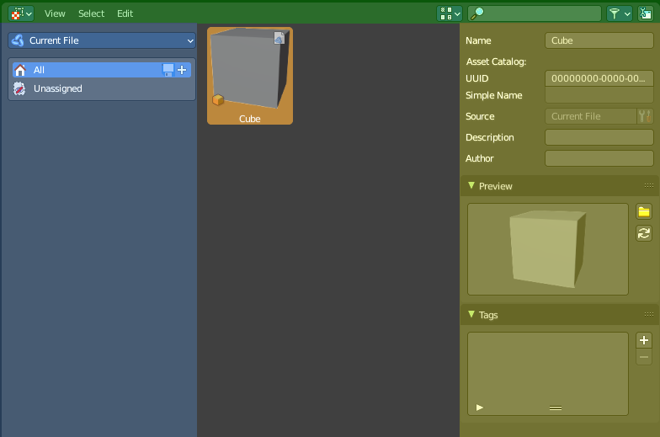
The Asset browser is an explorer dialog that allows you to store assets, and reuse them at a later point.
Assets can be everything. Objects, scenes, grease pencil strokes and so on.

The asset browser interface is divided into several areas.
Header (green)
Categories (blue)
Sidebar (yellow)
Content area ( no color)

How to

Asset handling
To insert or remove an asset you can use the right click menu in the outliner. Or the object menu in the 3d viewport. Mark Asset and Clear Asset.
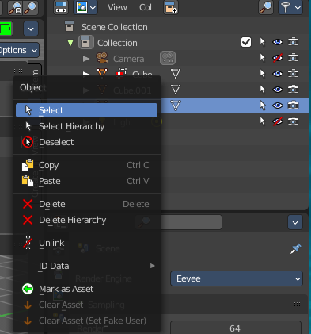
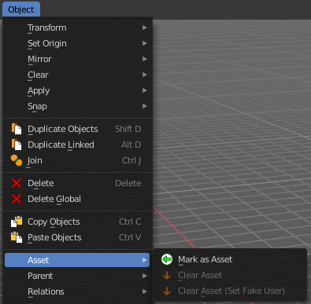

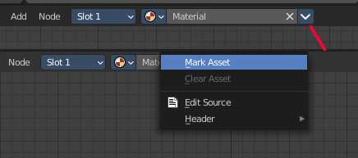
When it is something like a material or a texture, then you can also right click at the menu in the data prop. This will also reveal a menu where you can add or remove the asset.

Dragging items into the browser is currently not supported. The other direction works though. You can drag assets from the browser into the 3d view.
Poses can be inserted in pose mode. But how is currently not documented.

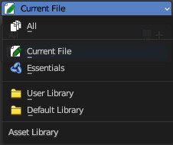
Asset Library
There are two ways to deal with assets. You can either store them in the current blend file for later use. This is the “Current file” method.
Or you can switch to “User Library”, and/or create an external library from a fixed path.
If you’d like to view all, select the “All” category.
To setup your external library, go to Preferences > File Paths > Asset Libraries to add this path to your asset libraries then. You can also do the same from header menu Catalog > Asset Library Paths.
You can add more than one asset library from the preferences.
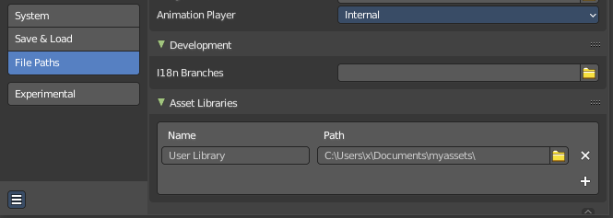
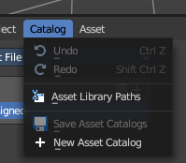

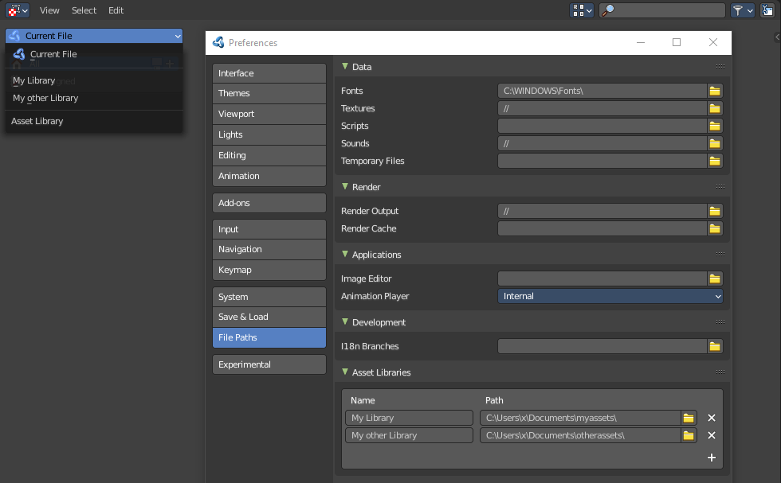
Drag n Drop of materials
Materials can be dragged directly at the material slots in the Properties Editor.

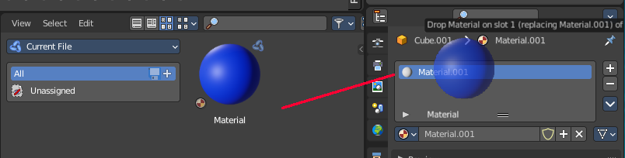

Header

There are several tools in the header to find. Menus, and a few options.

Header - View menu

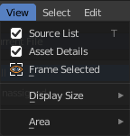
The view menu contains view related functionality.

Source List
Shows or hides the tool shelf at the left side.

File Path
Please ignore. This entry is a bug. The asset browser shares the code with the file browser.

Frame Selected
Scrolls the selection into view.

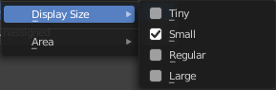
Display Size
The display size for the assets.

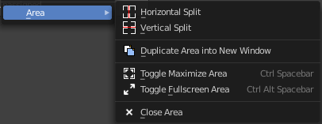
Area Menu
Area is a menu with window related settings.

Horizontal Split
Splits the editor horizontally into two editors.

Vertical Split
Splits the editor vertically into two editors.

Duplicate Area into new Window
Creates a floating window out of the current editor.

Toggle Maximize Area
Displays the editor maximized with menus.
To return to split view press hotkey Ctrl Up Arrow, or reuse the menu item in the View menu.

Toggle Fullscreen Area
Displays the editor maximized without menus.
To return from the full screen view press hotkey Alt F10, or use the little button that appears up right when you move the mouse in this corner.

Close Area
Closes the editor.

Header - Select menu

Select functionality.

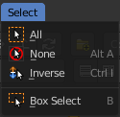
Box Select
Allows you to box select files. Note that this is an old obsolete operator. You don't need to press the hotkey anymore for box select.

Inverse
Inverts the selection.

None
Select none.

All
Select all.

Header - Catalog menu
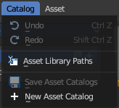

Undo
Undo of the last edit operation.

Redo
Redo of the last edit operation.

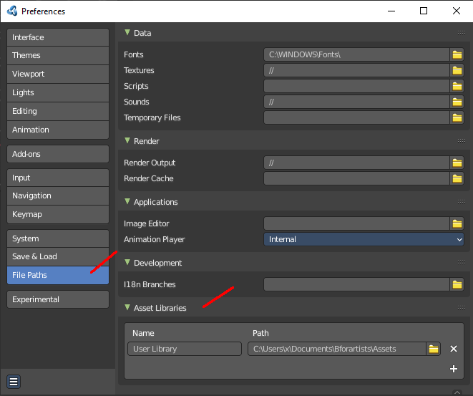
Asset Library Paths
Opens the file browser at the Paths tab. Here you can show, edit, and add paths to new asset libraries.

Save Asset Catalogs
Save all changed asset catalogs.

New Asset Catalog
Add a new asset catalog.

Header - Asset menu

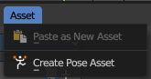
This menu contains asset related menu items.

Paste as new asset
Pastes a previously copied asset.

Create Pose Asset
Creates a pose asset from the selected armature.
Note: When you create a Pose Asset, it will capture what you see in the viewport from the active camera or view.

Use
To create a Pose Asset, follow these step:
- In the 3D View, select your Armature object and go into Pose Mode
- Select the bones you want to store as a pose
- In the Asset Browser Header Asset menu, use the operator Create Pose Asset
- This will create a Pose Asset in the Unassigned (Catalogue) category in the Current File.
- Click on the new Pose Asset in the Asset Shelf or Asset Browser to apply. Press and drag to apply with a slider strength.
- You can alternatively right click on the Pose Asset for alternative methods of applying the pose.

Header - Tools and Options

Drop Instance Collections at Origin
Drop the asset at mouse position or at the world origin in the 3d view.

Drop Collections as Instances
Drop the asset as instances of another object.
Note that this feature disables Drop Instance Collections at Origin since the asset now drops at the origin of the object.

Import Method
Allows you to define how to import the assets.

Follow Preferences
Use the import method as defined in the preferences.

Link
Link the asset at import.

Append
append the asset at import.

Append (Reuse Data)
append the asset at import. But avoid multiple copies of the asset.

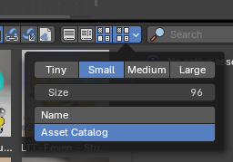
Display Mode
Allows you to switch between list view and thumbnail preview view.

Vertical List
Displays the content of the file browser as a vertical list.

Horizontal List
Displays the content of the file browser as a horizontal list.

Thumbnails
Displays the content of the file browser as thumbnails. This is especially of use for images or blend files with thumbnail preview.

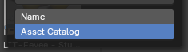
Sort by Name
Sort assets by alphabetical order, ignoring catalog order.

Sort by Asset Catalog
Sort assets by assigned alphabetical grouping based on catalog order, then ordering each asset in each catalog by alphabetical order.
Note: This is useful for large amount of assets to “group” catalogs of assets together.

Display mode options

Vertical / Horizontal List
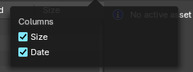
Shows the assets in a vertical list or in a column based horizontal list.

Size
Toggles the column with size information.

Date
Toggles the column with date information.

Thumbnails

Tiny / Small / Medium / Large Buttons
Preset display size of the thumbnails for the assets.

Size
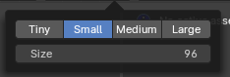
The display size of the thumbnails for the assets. The range for these thumbnails goes from tiny with 64 pixels up to large with 256 pixels.

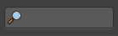
Search
Name Filter. Allows you to search for specific files and folders.

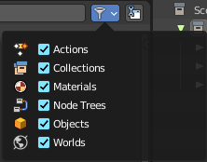
Filter
Allows you to filter the assets library in various ways. The menu items should be self explaining.

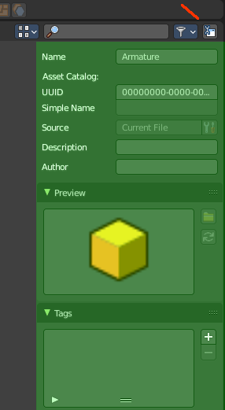
Toggle Region
Toggles the sidebar at the right. The sidebar contains various im- and export settings for the single file types.

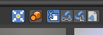
Drop collection as Instances
When it's on, you link collections as instances. When off, it links to scene. Default is off.

Drop collection at World Origin
When it's on, you link or append collections or collection as instances to world origin (center). When off, it links or appends to the mouse cursor. Default is off.
Note: When you link a collection to scene, not as an instance, and the world to origin is off, any concurring instances of the linked collection will have an offset. This is used to prevent any collection instance offsets to opt-in to linking in collections to scene at world origin, to later override or use as instance.

Import Method

Follow Preferences
Use the import method set in the Preferences for this asset library, don't override it.

Link
Import the assets as linked data

Append
Import the assets as copied data, with no link to the original asset data

Append (Reuse Data)
Import the assets as copied data-block while avoiding multiple copies of nested, typically heavy data. For example the textures of a material asset, or the mesh of an object asset, don't have to be copied every time this asset is imported. The instances of the asset share the data instead.

Tool shelf
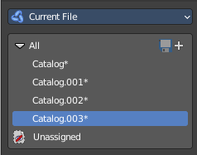

The toolshelf shows the different catalogs that you can use to store your assets.
These catalogs are currently disfunctional. You can just add or remove the categories. But not insert assets to it.

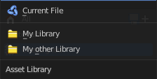
Asset Library chooser
Here you can choose what asset library to use.

Current File
Uses the current Blend file as the asset library. All assets are stored into the current blend file. And this means that when you remove objects from the scene, then the assets in the assets library will also vanish.

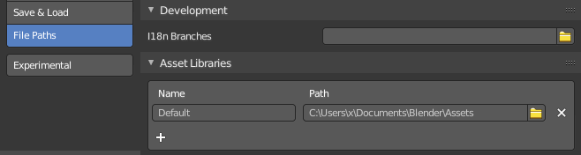
User Library
Uses the blend file in the path that is defined in the user preferences as the asset library.
Working with more than one blend file is currently not supported.

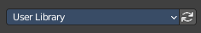
Refresh
With a user library you will get a refresh button besides the asset library chooser. Refreshes the content.

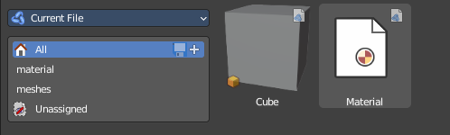
Asset Catalogs
Asset catalogs allows you to organize your assets.
Note that asset catalogs does not work with the external asset libraries. Just with the asset library in the current file.
First save your file. The method does not work at a blend file that is not saved yet.
Then create your catalog, and name them.
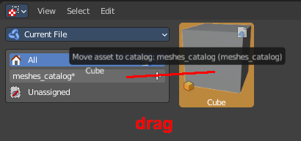
Then select one of your assets. And drag it onto the catalog that you want to add it to.

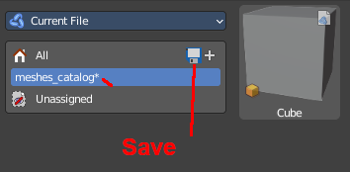
Finally, save the asset.

Save Asset Catalogs
Saves the current asset catalog to file and make the changes permanent.

New Asset Catalog
Creates a new asset catalog. Asset catalogs can be nested too.

Unassigned
The assets that are currently not in a catalog.

Asset catalog right click menus
Note that the Edit Source button is a developer feature.

Right clicking at the All item

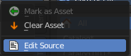
Mark as asset
Marks the object as an asset. Dysfunctional in this context.

Clear Asset
Removes all assets.

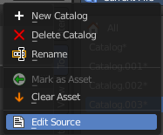
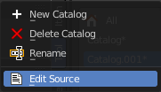
Right clicking at one of the catalog items
Content depends if you have an asset selected or not.

New Catalog
Creates a new nested catalog inside of the current catalog.

Delete catalog
Deletes the catalog and all of its childs.

Rename
Rename the current catalog.

Mark as asset
Marks the object as an asset. Dysfunctional in this context.

Clear Asset
Removes all assets.

Sidebar

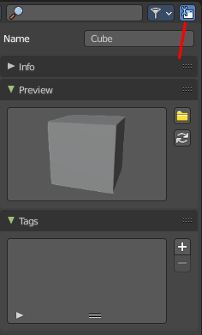
At the right side you will find the Sidebar. It is usually hidden. But can be revealed by a click at the litte triangle button, or with a click at the Toggle Region button in the header at the right.

Name
The name of the asset. Here you can also rename the asset. Note that the name of the asset in the view does not refresh immediately at the moment. You can force a refresh of it in the Preview panel by clicking at the Generate Preview button

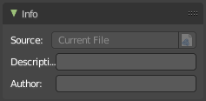
Info Panel
Some additional infos about the asset.

Source
A source that can't be edited for the Blender developers.

Description
Add a description for the asset.

Author
Add the name of the author of the asset.

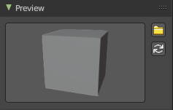
Preview Panel
A preview of the asset. By default the same image that you see in the view when you create the asset.

Load Custom Preview
Opens a file browser where you can choose a custom icon for this asset.

Generate Preview
Genereates a preview icon from the content. Note that this will reset the custom icon.

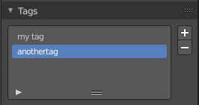
Tags Panel
Enter custom tags for this asset. This tags allows you to sort your assets by tag.

Tags List
The list of the current tags.

Drag handler
Allows you to resize the list.

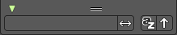
Search
Search the list. This search can be expanded by clicking at the little triangle button down left.

Add Asset Tag
Adds a tag to the tag list. This tag can be renamed in the list.

Remove Asset Tag
Removes the selected tag from the tag list.

Assets context menu

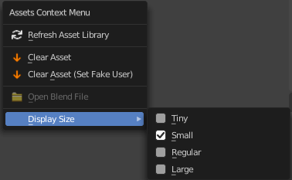
When you right click into the view then an Asset context menu opens.

Refresh Asset Library
Refresh the file list.

Clear Asset
Removes the asset from the asset library.

Clear Asset ( Set Fake User)
Removes the asset from the asset library. But sets it to fake user, so that it remains in the scene.

Open Blend File
Opens the path for the blend file that contains the active asset. Just active with User Library.

Display Size
Set the display size of the file browser to four predefined sizes.

Pose Assets context menu
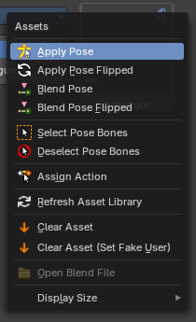
When you right click on a pose asset in the Asset Browser or 3D View Asset shelf, you get extra options to help apply the pose. To use them, make sure you have a compatible armature selected, are in Pose Mode and have the bones you’d like to pose selected.
Note: Pose action assets are single keyframe action clips marked as assets either from the NLA or the Dopesheet editors. Animation keyframe sequences cannot be marked as assets.

Apply Pose
Apply the given pose action to the active rig. When you select this, this will apply the pose to selected bones.

Apply Pose Flipped
Apply the given pose action to the active rig with a flipped axis. When you select this, this will apply the flipped pose to selected bones. Flipping happens usually from bones labeled .L and .R

Blend Pose
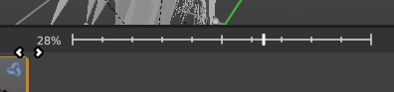
Blend the given pose action to the active rig. This is useful to interpolate from the original pose to the new pose. When using, you will see a slider in the asset browser header giving you a degree of blend.

Blend Pose Flipped
Blends the selected bones with the flipped Pose asset.

Select Pose Bones
Select those bones used in this pose action. This will select all the necessary bones you need to apply the pose effectively. If you have no bones selected, the pose will not apply. Poses only apply to bones that are selected.

Deselect Pose Bones
Deselect those bones used in this pose action. This will ultimately clear the selection based on the pose action bones defined in the marked action clip.

Assign Action
Set the pose action as the active action on the active object. This will ultimately load the pose action animation clip to the Action Editor of the Dopesheet, allowing you to edit the pose. This only works in the source file with the marked poses.

